We can use few technique to calculate the depth data by using camera and emitter:

1. spackled IR light,
2. structured light pattern
3. Time of flight approach
4. Laser Beam Scanning
5. Stereo vision (Interchange the camera with emitter and take left and right image)

I have used the Laser beam scanning approach. In this case, laser beam is projected on the object and camera capture the images which contain edges and curves. Depth is calculated by parameters.

Libraries Used: OpenCV and PCL

**Flowchart:**

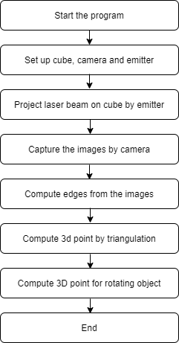

**Future work:**

1. Calculation of depth image for rotating object
2. Use OpenGL for better 3D simulation:

Plan:

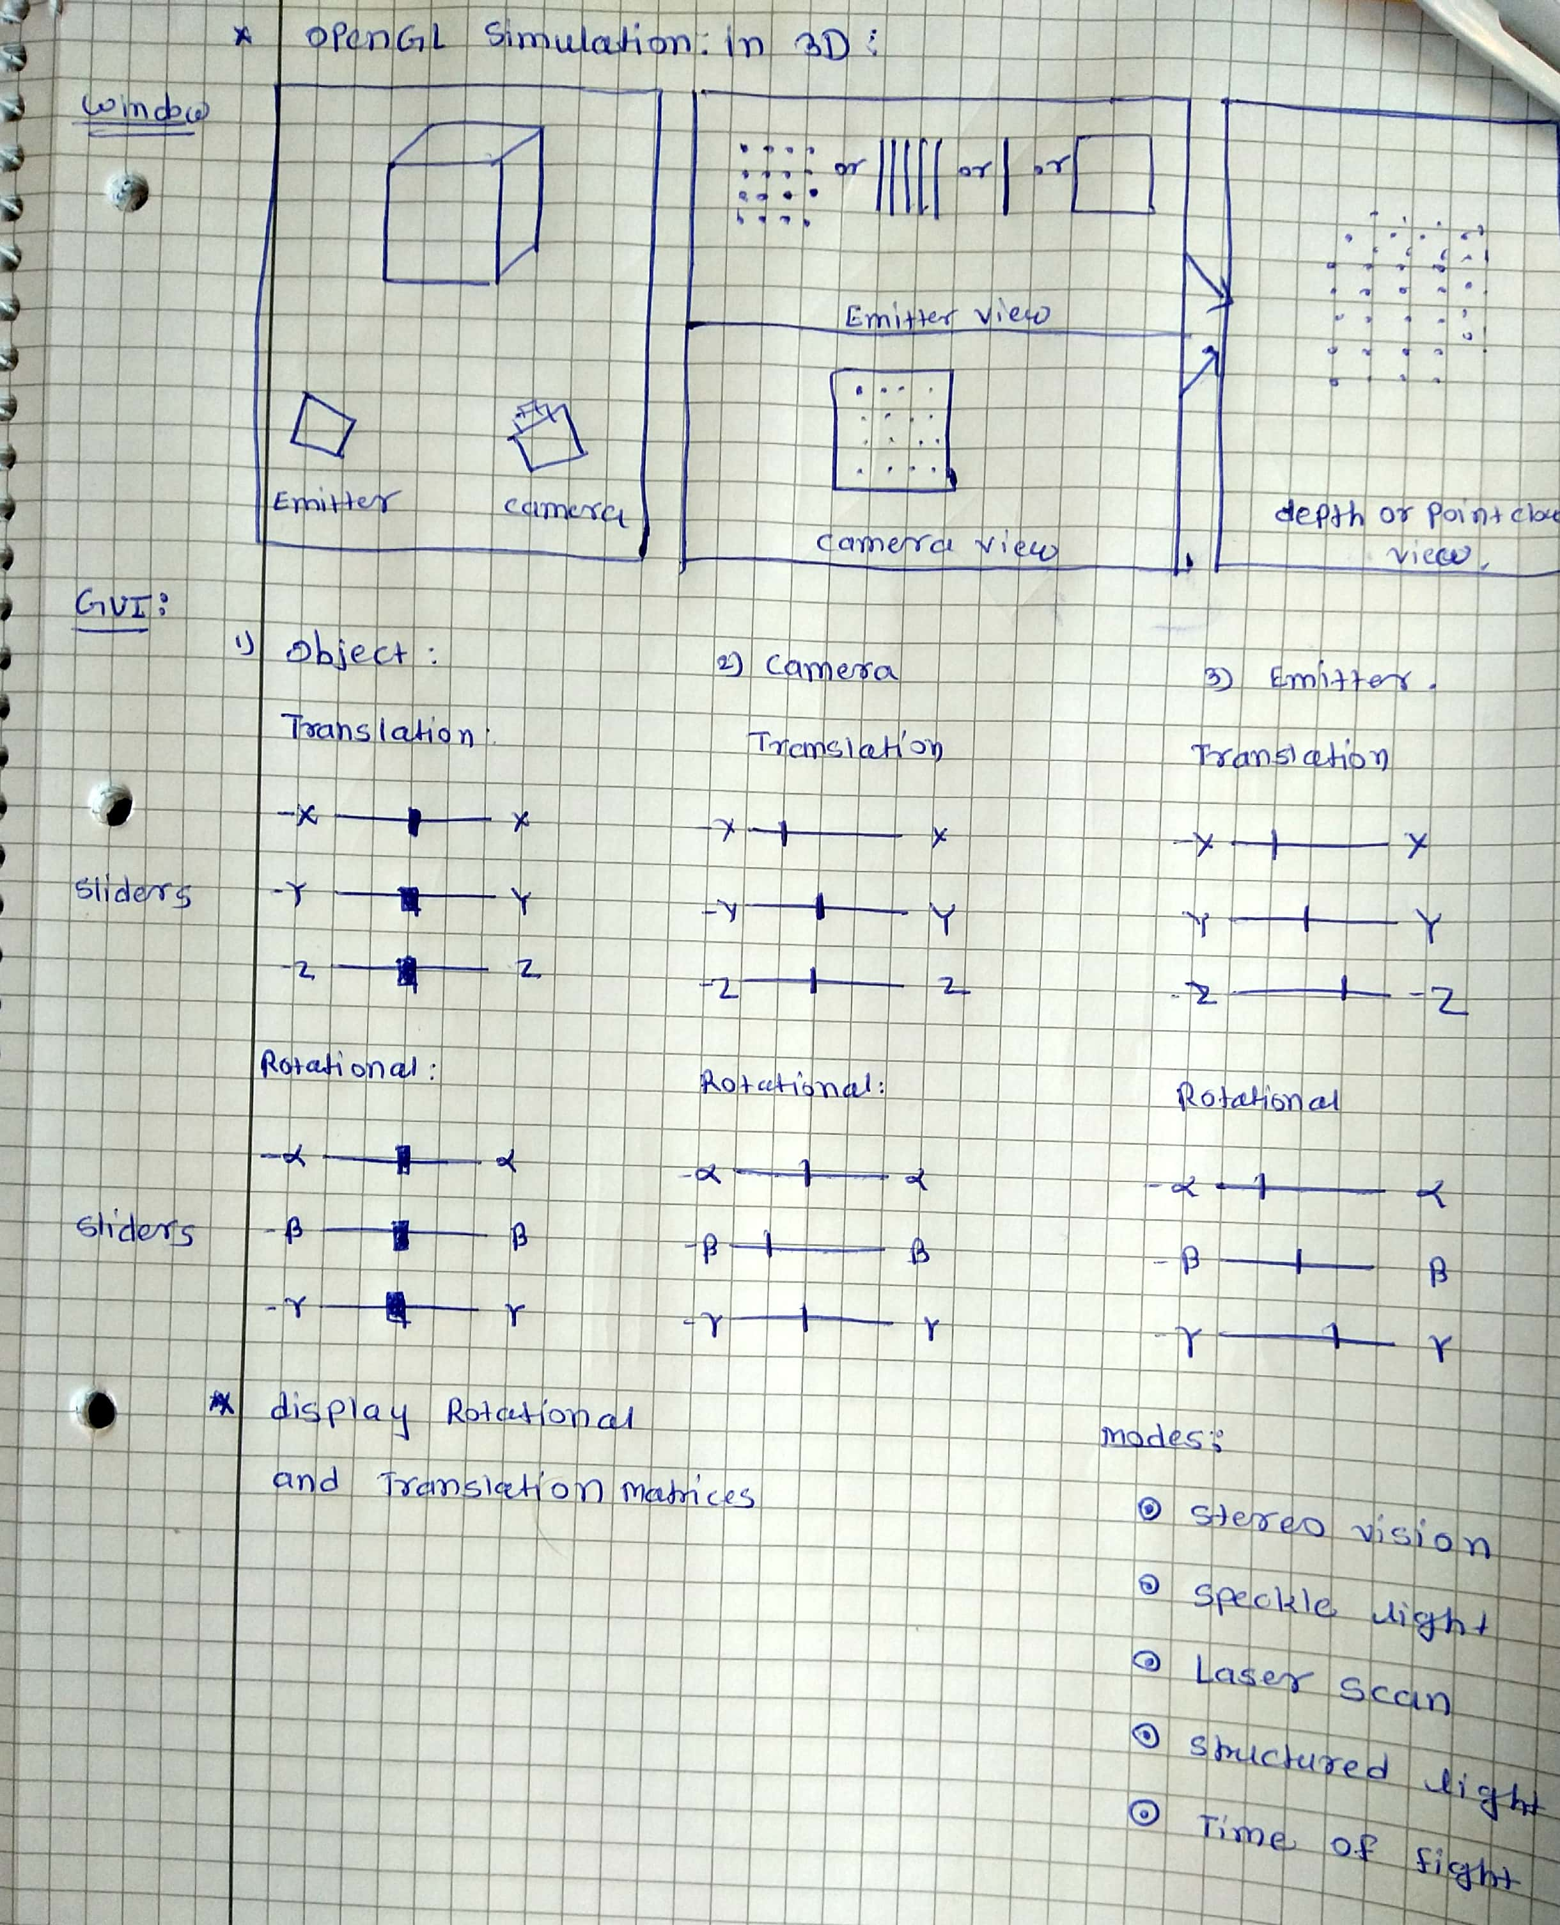

**Task Checklist:**

1. Camera matrix using the Pinhole Model : Completed

2. Solid cube object; this object must have a width [mm], height [mm] and depth properties [mm] of a 3D solid cube : Completed

3. Cube position in a world coordinate system; take one corner point of the cube as the origin (rotation in Rodrigues form [rad], translation [mm]). The origin of the world is not equal origin of the cube! : Completed

4. Emitter field of view in vertical [rad] and horizontal axis [rad] : Completed

5. Emitter resolution in vertical and horizontal axis (row and column) : Completed

6. Emitter position in camera coordinate system (rotation in Rodrigues form [rad], translation [mm]) : Completed

6. Set of camera positions with respect to the world coordinate system (rotation in Rodrigues form [rad], translation [mm]) : Completed

7. Output folder for the image results : Completed

1. Create a function in C++ that produces a depth image of the cube from different camera perspectives. Remember that the position of IR emitter is fixed with respect to the cam-era: Completed

2. Provide a sample script that uses the function implemented in task 1; this script must produce : at least six result-images from different camera positions (rotations and translations): one result is represented

3. Provide sample results from the function implemented in task 1: Completed

%3CmxGraphModel%3E%3Croot%3E%3CmxCell%20id%3D%220%22%2F%3E%3CmxCell%20id%3D%221%22%20parent%3D%220%22%2F%3E%3CmxCell%20id%3D%222%22%20style%3D%22edgeStyle%3DorthogonalEdgeStyle%3Brounded%3D0%3BorthogonalLoop%3D1%3BjettySize%3Dauto%3Bhtml%3D1%3BexitX%3D0.5%3BexitY%3D1%3BexitDx%3D0%3BexitDy%3D0%3BentryX%3D0.5%3BentryY%3D0%3BentryDx%3D0%3BentryDy%3D0%3B%22%20edge%3D%221%22%20source%3D%223%22%20target%3D%224%22%20parent%3D%221%22%3E%3CmxGeometry%20relative%3D%221%22%20as%3D%22geometry%22%2F%3E%3C%2FmxCell%3E%3CmxCell%20id%3D%223%22%20value%3D%22Start%20the%20program%22%20style%3D%22rounded%3D1%3BwhiteSpace%3Dwrap%3Bhtml%3D1%3BfontSize%3D12%3Bglass%3D0%3BstrokeWidth%3D1%3Bshadow%3D0%3B%22%20vertex%3D%221%22%20parent%3D%221%22%3E%3CmxGeometry%20x%3D%22160%22%20y%3D%2280%22%20width%3D%22240%22%20height%3D%2240%22%20as%3D%22geometry%22%2F%3E%3C%2FmxCell%3E%3CmxCell%20id%3D%224%22%20value%3D%22Set%20up%20cube%2C%20camera%20and%20emitter%22%20style%3D%22rounded%3D1%3BwhiteSpace%3Dwrap%3Bhtml%3D1%3BfontSize%3D12%3Bglass%3D0%3BstrokeWidth%3D1%3Bshadow%3D0%3B%22%20vertex%3D%221%22%20parent%3D%221%22%3E%3CmxGeometry%20x%3D%22160%22%20y%3D%22140%22%20width%3D%22240%22%20height%3D%2240%22%20as%3D%22geometry%22%2F%3E%3C%2FmxCell%3E%3CmxCell%20id%3D%225%22%20style%3D%22edgeStyle%3DorthogonalEdgeStyle%3Brounded%3D0%3BorthogonalLoop%3D1%3BjettySize%3Dauto%3Bhtml%3D1%3BexitX%3D0.5%3BexitY%3D1%3BexitDx%3D0%3BexitDy%3D0%3BentryX%3D0.5%3BentryY%3D0%3BentryDx%3D0%3BentryDy%3D0%3B%22%20edge%3D%221%22%20parent%3D%221%22%3E%3CmxGeometry%20relative%3D%221%22%20as%3D%22geometry%22%3E%3CmxPoint%20x%3D%22280%22%20y%3D%22179%22%20as%3D%22sourcePoint%22%2F%3E%3CmxPoint%20x%3D%22280%22%20y%3D%22199%22%20as%3D%22targetPoint%22%2F%3E%3C%2FmxGeometry%3E%3C%2FmxCell%3E%3CmxCell%20id%3D%226%22%20value%3D%22Project%20laser%20beam%20on%20cube%20by%20emitter%22%20style%3D%22rounded%3D1%3BwhiteSpace%3Dwrap%3Bhtml%3D1%3BfontSize%3D12%3Bglass%3D0%3BstrokeWidth%3D1%3Bshadow%3D0%3B%22%20vertex%3D%221%22%20parent%3D%221%22%3E%3CmxGeometry%20x%3D%22160%22%20y%3D%22200%22%20width%3D%22240%22%20height%3D%2240%22%20as%3D%22geometry%22%2F%3E%3C%2FmxCell%3E%3CmxCell%20id%3D%227%22%20value%3D%22Capture%20the%20images%20by%20camera%22%20style%3D%22rounded%3D1%3BwhiteSpace%3Dwrap%3Bhtml%3D1%3BfontSize%3D12%3Bglass%3D0%3BstrokeWidth%3D1%3Bshadow%3D0%3B%22%20vertex%3D%221%22%20parent%3D%221%22%3E%3CmxGeometry%20x%3D%22160%22%20y%3D%22260%22%20width%3D%22240%22%20height%3D%2240%22%20as%3D%22geometry%22%2F%3E%3C%2FmxCell%3E%3CmxCell%20id%3D%228%22%20style%3D%22edgeStyle%3DorthogonalEdgeStyle%3Brounded%3D0%3BorthogonalLoop%3D1%3BjettySize%3Dauto%3Bhtml%3D1%3BexitX%3D0.5%3BexitY%3D1%3BexitDx%3D0%3BexitDy%3D0%3BentryX%3D0.5%3BentryY%3D0%3BentryDx%3D0%3BentryDy%3D0%3B%22%20edge%3D%221%22%20parent%3D%221%22%3E%3CmxGeometry%20relative%3D%221%22%20as%3D%22geometry%22%3E%3CmxPoint%20x%3D%22281%22%20y%3D%22240%22%20as%3D%22sourcePoint%22%2F%3E%3CmxPoint%20x%3D%22281%22%20y%3D%22260%22%20as%3D%22targetPoint%22%2F%3E%3C%2FmxGeometry%3E%3C%2FmxCell%3E%3CmxCell%20id%3D%229%22%20value%3D%22Compute%203d%20point%20by%20triangulation%22%20style%3D%22rounded%3D1%3BwhiteSpace%3Dwrap%3Bhtml%3D1%3BfontSize%3D12%3Bglass%3D0%3BstrokeWidth%3D1%3Bshadow%3D0%3B%22%20vertex%3D%221%22%20parent%3D%221%22%3E%3CmxGeometry%20x%3D%22160%22%20y%3D%22380%22%20width%3D%22240%22%20height%3D%2240%22%20as%3D%22geometry%22%2F%3E%3C%2FmxCell%3E%3CmxCell%20id%3D%2210%22%20style%3D%22edgeStyle%3DorthogonalEdgeStyle%3Brounded%3D0%3BorthogonalLoop%3D1%3BjettySize%3Dauto%3Bhtml%3D1%3BexitX%3D0.5%3BexitY%3D1%3BexitDx%3D0%3BexitDy%3D0%3BentryX%3D0.5%3BentryY%3D0%3BentryDx%3D0%3BentryDy%3D0%3B%22%20edge%3D%221%22%20parent%3D%221%22%3E%3CmxGeometry%20relative%3D%221%22%20as%3D%22geometry%22%3E%3CmxPoint%20x%3D%22280%22%20y%3D%22301%22%20as%3D%22sourcePoint%22%2F%3E%3CmxPoint%20x%3D%22280%22%20y%3D%22321%22%20as%3D%22targetPoint%22%2F%3E%3C%2FmxGeometry%3E%3C%2FmxCell%3E%3CmxCell%20id%3D%2211%22%20value%3D%22Compute%20edges%20from%20the%20images%22%20style%3D%22rounded%3D1%3BwhiteSpace%3Dwrap%3Bhtml%3D1%3BfontSize%3D12%3Bglass%3D0%3BstrokeWidth%3D1%3Bshadow%3D0%3B%22%20vertex%3D%221%22%20parent%3D%221%22%3E%3CmxGeometry%20x%3D%22160%22%20y%3D%22320%22%20width%3D%22240%22%20height%3D%2240%22%20as%3D%22geometry%22%2F%3E%3C%2FmxCell%3E%3CmxCell%20id%3D%2212%22%20style%3D%22edgeStyle%3DorthogonalEdgeStyle%3Brounded%3D0%3BorthogonalLoop%3D1%3BjettySize%3Dauto%3Bhtml%3D1%3BexitX%3D0.5%3BexitY%3D1%3BexitDx%3D0%3BexitDy%3D0%3BentryX%3D0.5%3BentryY%3D0%3BentryDx%3D0%3BentryDy%3D0%3B%22%20edge%3D%221%22%20parent%3D%221%22%3E%3CmxGeometry%20relative%3D%221%22%20as%3D%22geometry%22%3E%3CmxPoint%20x%3D%22281%22%20y%3D%22359%22%20as%3D%22sourcePoint%22%2F%3E%3CmxPoint%20x%3D%22281%22%20y%3D%22379%22%20as%3D%22targetPoint%22%2F%3E%3C%2FmxGeometry%3E%3C%2FmxCell%3E%3CmxCell%20id%3D%2213%22%20value%3D%22Compute%203d%20point%20by%20triangulation%22%20style%3D%22rounded%3D1%3BwhiteSpace%3Dwrap%3Bhtml%3D1%3BfontSize%3D12%3Bglass%3D0%3BstrokeWidth%3D1%3Bshadow%3D0%3B%22%20vertex%3D%221%22%20parent%3D%221%22%3E%3CmxGeometry%20x%3D%22160%22%20y%3D%22440%22%20width%3D%22240%22%20height%3D%2240%22%20as%3D%22geometry%22%2F%3E%3C%2FmxCell%3E%3CmxCell%20id%3D%2214%22%20style%3D%22edgeStyle%3DorthogonalEdgeStyle%3Brounded%3D0%3BorthogonalLoop%3D1%3BjettySize%3Dauto%3Bhtml%3D1%3BexitX%3D0.5%3BexitY%3D1%3BexitDx%3D0%3BexitDy%3D0%3BentryX%3D0.5%3BentryY%3D0%3BentryDx%3D0%3BentryDy%3D0%3B%22%20edge%3D%221%22%20parent%3D%221%22%3E%3CmxGeometry%20relative%3D%221%22%20as%3D%22geometry%22%3E%3CmxPoint%20x%3D%22281%22%20y%3D%22421%22%20as%3D%22sourcePoint%22%2F%3E%3CmxPoint%20x%3D%22281%22%20y%3D%22441%22%20as%3D%22targetPoint%22%2F%3E%3C%2FmxGeometry%3E%3C%2FmxCell%3E%3C%2Froot%3E%3C%2FmxGraphModel%3E